***MEMORANDUM***

***Comptech Education Society***

***AS UNDER GOVT. SOCIETY ACT***

**Reg. Office : J/97 Anand Nagar Adhartal Jabalpur – 482004 (Madhya Pradesh ) India**

**Head Office : 1462/A Gayatri Nagar Adhartal Jabalpur – 482004 (Madhya Pradesh) India**

**Contact No. : +918103666685, +917803994492 Email :** [**cesjbp@gmail.com,nklakhera@gmail.com**](mailto:cesjbp@gmail.com,nklakhera@gmail.com)

**Introduction**

Comptech Education Society is a public charitable society, deed executed under the societies registration Act.

Comptech Education Society has been formed with an objective for public and charitable purpose and its income shall also be wholly for the public and charitable purpose without prejudice and discrimination on the basis of cast, language or religion.

**Incorporation & Registration**

Comptech Education Society is a society registered under societies registration act of vide registration no. JJ/6051 on 6th day of May 2002.

**Objects of the Society**

The objectives of the Society shall be wholly for public and charitable purpose and its income shall also be wholly for the public and charitable purpose without prejudice, discrimination on the basis on the basis of cast, religion. The society shall have the following objectives :

1. To undertake and conduct welfare and development project in the field of education, health, environment and income generation.
2. To provide basic facilities to underprivileged sections such as food, clothing, shelter, safe drinking water, education, electricity, toilets etc.
3. To provide vocational training to women and other weaker social sections in order to make them self dependent and generate a feeling of entrepreneurship with the help of the schemes such as self-help group.
4. To work for environment protection and sustainable development through community mobilization at grass-root-level.
5. To make science popular among the youths and encourage research in various branches of science & technology.
6. To provide relief to effected communities at the time of natural disasters such as floods, drought, earthquakes, landslide etc. and to promote higher research in the field of disaster management.
7. To provide rehabilitation facilities such as drug abuse prevention, mental healthcare to improve the quality of life and in the inculcation of such behavior as would bring happiness to mankind without reservation of status, cast and religion.
8. To render and provide such assistance, facilities and environment for the empowerment of the women, children and old-aged for treatment and medical care that they cannot otherwise afford, which will, in the option of trustees, promote the welfare of the woman at large.
9. To provide educational, vocational and professional guidance and impart training in various fields to rehabilitate the mentally and physically handicaps.
10. To provide, organize, maintain, control, develop and conduct programs and projects, both agricultural, industrial and otherwise for members of various societies, which will lead to crime prevention and rehabilitation of people.
11. To establish, run teaching medical college, paramedical colleges nursing colleges, pharmacy colleges so that such institutions could also serve the purpose of providing the requisite clinical training necessary for medical studies and act as necessary adjuncts to medical education.
12. To establish, maintain and run primary school, residential schools, high schools, arts and science colleges, to impart knowledge in primary education, in arts and science, legal and religious subjects.
13. To set up hospitals/nursing homes and assist hospitals in the setting up various facilities such as blood banks, eye banks, burn centers, etc. for the poor patients.
14. Undertake, encourage, promote and associate with the integrated rural & urban development programs and schemes to support and supplement various policies and programs of central state governments.
15. Impart education and training to poor but deserving students by way of stipends, scholarships, research, fellowships, teaching, fellowships free boarding and lodging, free gifts, of book teaching aids, instrument and equipments.
16. Provide industrial education. Research and training for all segments at all levels, viz. craftsmen. Technicians, professional and post graduates courses, training before and after educations and during vacations skills, arts and crafts as well as traders and braches of engineering, technology, industry, commerce and applied arts, bio technology, agriculture, horticulture, sericulture, forestry, textile, industrial design home science, dietetics and nutrition tourism information and technology etc.
17. Provide opportunities for integrating the education and the training with the needs of the socio- economic development, urban development tribal development and such other new disciplines and specialties through the establishment of research and training cum production centre.
18. To institute scholarships, stipends, medals, prizes etc. to help and encourage deserving students and to provide monetary aid to students, scholars and teachers for pursuing their educational activites.
19. To provide training computer education and awareness programs.
20. To provide employments details and courses to educated unemployed persons.
21. To run employment programs drawing, painting, craft work, tailoring work.
22. To provide free training camp and exhibition time to time.
23. To provide special help for mantely and physically handicapped students.
24. For Women empowerment special employment courses run by society.
25. To provide employment training Poor and helpless women, children’s, students, and communities.
26. Free prod education and awareness programs provide by society.
27. To provide education and training in organic forming and inorganic forming, agriculture technology based education.
28. Development in rural area clean area, watershed, animals shed educate people for cleanness.
29. To provide awareness programs for organic materials marketing in rural and urban area.
30. To provide training for employment in milk society and training provide for sales, management and education for employment.
31. To assist financial management and employment education in rural area.
32. To provide schemes for women and child labors as govt act.
33. To provide special training for Sc, St,Obc, and special st students.
34. To provide computer education for poor and low income person
35. To provide accidental insurance policy, agriculture insurance policy, pension policy in rural area.
36. To run Agriculture land safety programs, formers crop insurance and awareness programs for formers crop insurance.
37. Development in rural area for drinking water, Nirmal and Javik gram.
38. To organize & maintain sports Games, cultural and all type of competitive activites for development of the youngsters.
39. To remove poorness and unemployment. Start and maintain professional and informal activities. And to establish units for Home crafts, Small crafts for development of craft and informal activities and to provide proper encouragement.
40. To handle concerned activities through which all communities and castes of the society may live peaceable and with justice.
41. To provide necessary support to the handicapped, elders, shelter less person etc. of the society.
42. To do necessary efforts to provide residents, drinking water, drainage, electric connection, toilet etc, to people of the society to improve their life standards and provide support for the same,
43. To encourage youngster’s society, female society and provide necessary support to them.
44. Can handle all activities relating to environment, rural area development, formers improvements, safe water yojna, and etc.
45. Comptech Education Society work to more subjects without any caste, religion and languages.

**Various Programes run by the Society**

Comptech Education Society has been organizing various charitable and awareness program of general public utility for the betterment of the Society and humanity. The purpose of conducting such programs is to create well educated, skilled, equipped and healthy society as well as nation.

**Educational Seminars**

Educational seminars were organized by Society on educatiuonal topics like the general knowledge quiz,cooking competition etc. at schools.Many students participated in these programs. In this program man games have been arranged like quiz, Painting competition and prizes were distributed & lunch served to the participating students.



**Consumer Awareness Camp**

Our one of the main objective to create educated and healthy nation, hence forth knowing of consumer rights and privileges make a reasonable sense. Therefore the program was held to make people awareness of such rights and privileges.

**Vocational training Program for women**

Vocational training was organized with a view to make the women independent and to develop internal confidence in them. The training involves various skill developing activities such as computer training, cloth stitching etc. The purpose of the program was also to make them capable of earning money in order to easy and honorable maintenance of their social status and also to meet personal expenditure.

 

**Free medical Check-up Camp**

Health check-up camps were frequently and periodically organized by Comptech Education Society in order to archive the better health of the society and nation. The program was mainly oriented towards weaker and poor section of the society. In this programs Blood tests, free eye and ear check up, free dental check up, free doctor consultancy, free medicines were provide.

**Book Fair & Awareness Program**

Book fair and awareness program was organized by the Comptech Education Society. Since the major objective of the foundation is contributing towards the development and achievement of the education therefore the book and knowledge get top priority, Hence the foundation organizes such type of the program. In this program books of various great authors on science, arts, fine arts, culture, literature, general knowledge, etc. were displayed as well as books were distributed to desirous and needy people.



**Children Health Check-up Program**

Children are the pillar of the future development of the society as well as the country. Therefore the good health of the children has the greater impact on the country’s future. The Comptech Education society time to time organizes the children health check up program. The motive of the program is to make awareness of the children about various health issues. The children were made conscious about health through various videos, audios, and posters. Free health checkup such as blood test, stool test, urine test, serum test and other necessary tests were conducted, in addition free doctor’s consultancy was provided and also medicines were distributed free of cost.



**Organic Forming Training Program**

Comptech Education Society has been organized organic forming training program in rural area. Our team give training formers and trained in Javik Khad, Javik Pesticide, and its product used in Javik Krishi. Our team organized free training camp in rural area. In this camp we arrange agriculture consultant, soil consultant, etc. given free training to formers for better organic forming.

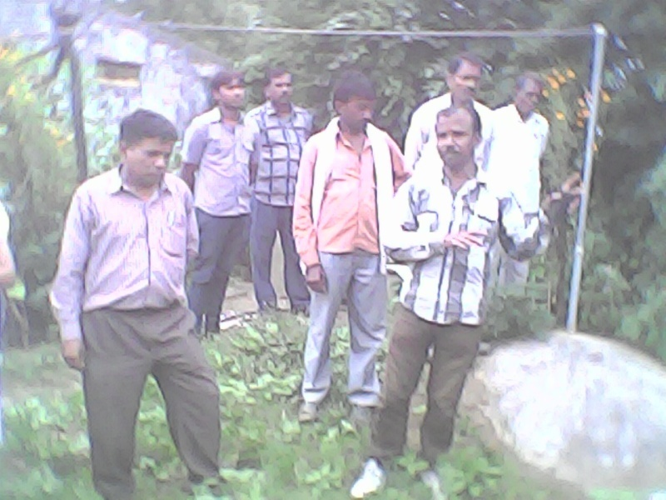

Practical training in Form with govt.officers

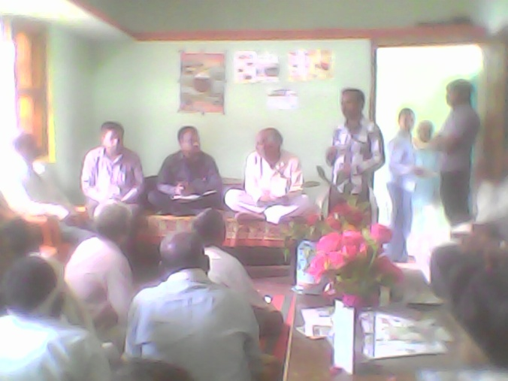

Forming Education training in rural area

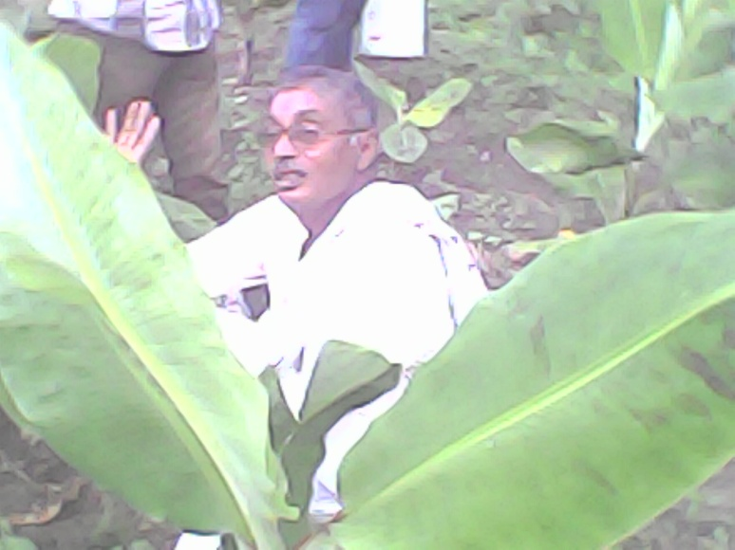

Training program in form house

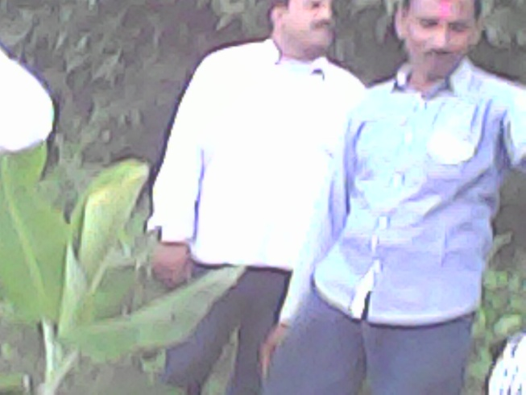 Training Program in form house

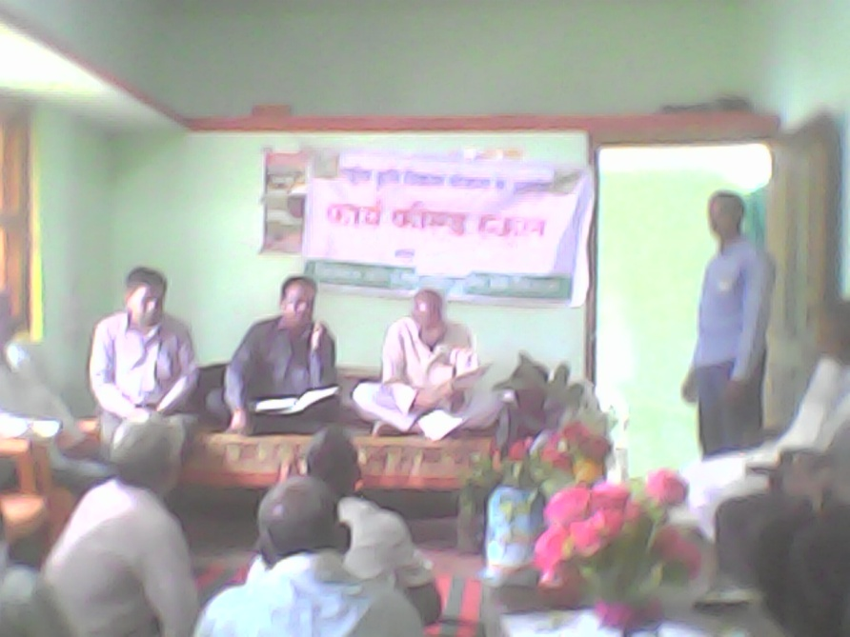

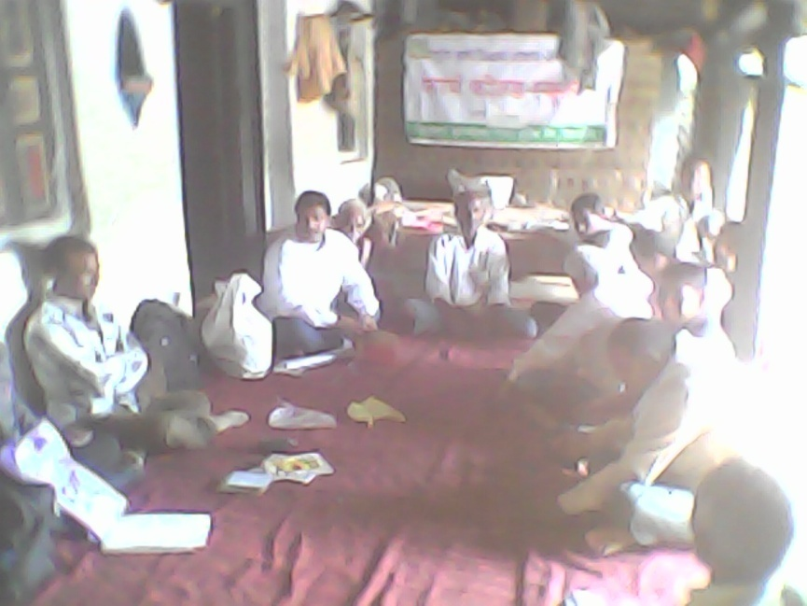

Education program in Rural area with Krishi karya shala

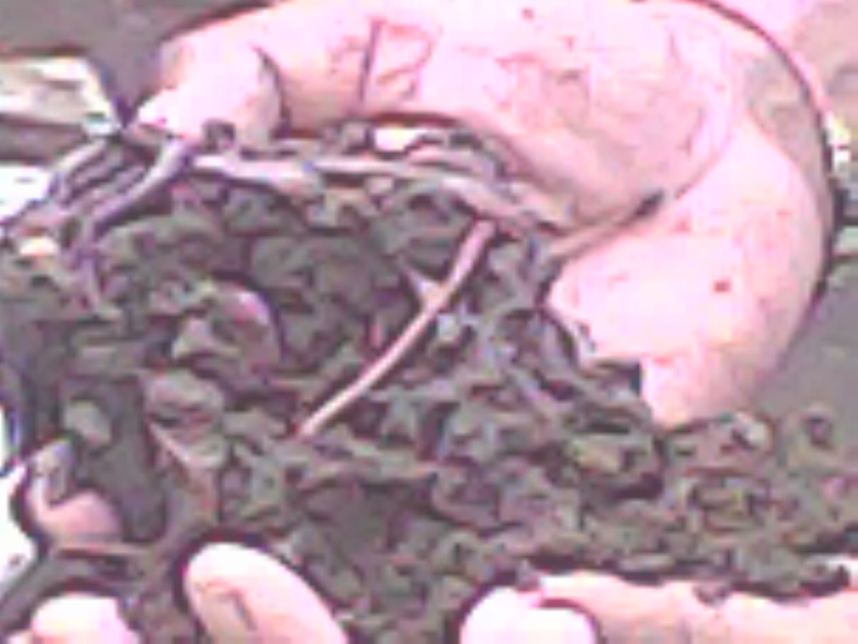

**Picture of Vermi compost khad**

**List of Members of Comptech Education Society Jabalpur**

* **President – Narendra Lakhera**

**J/97 Anand Nagar Adhartal Jabalpur -482004 (M.P.)**

* **Vice President – Shri Jivendra Panday**

**90 Quarter Vijay Nagar Krishi Upaj Mandi Jabalpur – 482002**

* **Secretary – Shri Naresh Kushwaha**

**Ranital Chowk Main Road Jabalpur – 482002**

* **Co secretary – Rajiv Sarkar**

**Ashok Nagar Adhartal Jabalpur – 482004**

* **Treasure - Shri C.P.Lakhera**

**J/97 Anand Nagar Adhartal Jabalpur – 482004**

* **Members – Shahid Khan**

**Pasiyana Mohalla Near Masjid Takkar Gram Jabalpur – 482004**

* **Members – Vijay Chourasiya**

**Tilak Bhumi Ki Talaiya Bhaldarpura Jabalpur – 482004**